**Breast Cancer Risk Prediction**

**1.INTRODUCTION:**

**1.1.OVERVIEW:**

Breast cancer is one of the main causes of cancer death worldwide. Computer-aided diagnosis systems showed the potential for improving diagnostic accuracy. But early detection and prevention can significantly reduce the chances of death. It is important to detect breast cancer as early as possible.

**1.2.PURPOSE:**

Breast cancer risk prediction algorithms are used to **identify subpopulations that are at increased risk for developing breast cancer**. They can be based on many different sources of data such as demographics, relatives with cancer, gene expression, and various phenotypic features such as breast density.

**2.LITERATURE SURVEY:-**

**2.1. Existing problem:-**

Breast cancer is an increasing public health problem. Substantial advances have been made in the treatment of breast cancer, but the introduction of methods to predict women at elevated risk and prevent the disease has been less successful. Here, we summarize recent data on newer approaches to risk prediction, available approaches to prevention, how new approaches may be made, and the difficult problem of using what we already know to prevent breast cancer in populations.

**2.2. Proposed solution:-**

* The proposed solution for the problem is first we need to collect the data related to the Breast Cancer Risk Prediction.
* According to the collected data we perform different actions for getting the Exact Information about Breast Cancer Risk Prediction.
* We Will classify images into two classifications of malignant and benign. As early diagnostics significantly increases the chances of correct treatment and survival. In this application, we are helping the doctors and patients to classify the Type of Tumour for the specific image given with the help of Neural Networks.

**3.THEORITICAL ANALYSIS:-**

**3.1.Technical Architecture:**

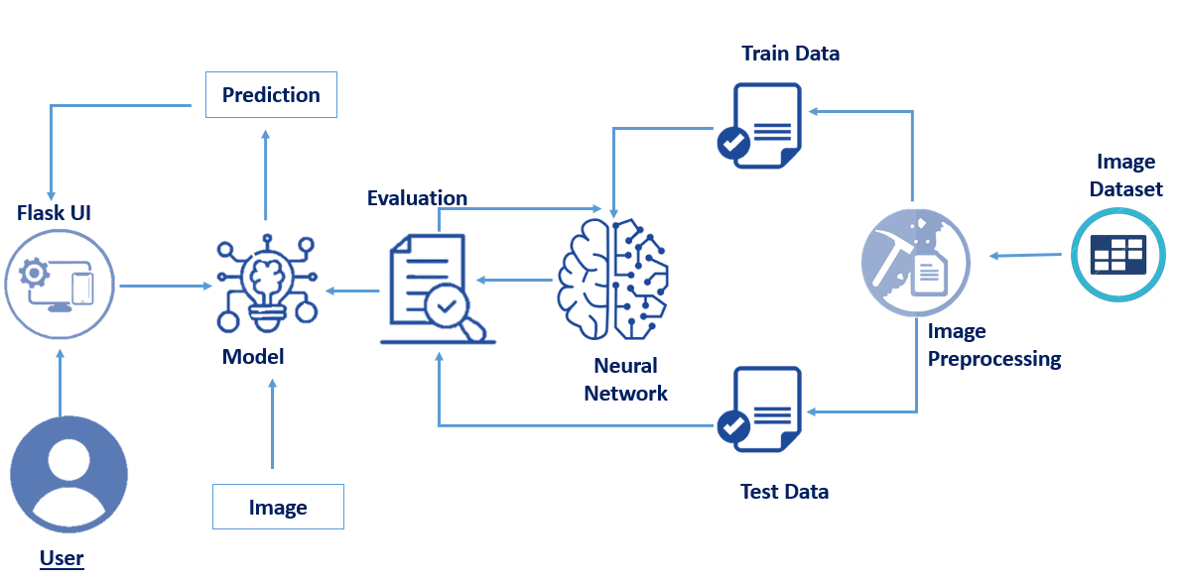

**3.2.Hardware/software designing**

**Software Requirements:**

* OS – Windows XP,7,8,10
* Jupyter Software
* Spyder Software
* Anaconda Command Prompt

**Hardware Components:**

* Processor – i3
* Hard Disk Storage – 10 GB
* RAM – 1GB

**4.EXPERIMENTAL INVESTIGATIONS:-**

The goal is to classify images into two classifications of malignant and benign. As early diagnostics significantly increases the chances of correct treatment and survival. In this application, we are helping the doctors and patients to classify the Type of Tumour for the specific image given with the help of Neural Networks.

**5.Results:-**

Image Pre-processing includes the following main tasks

* Import ImageDataGenerator Library.
* Configure ImageDataGenerator Class.
* Applying ImageDataGenerator functionality to the trainset and test set.
* The model is to be tested with different images to know if it is predicting correctly.
* After the model is built, we will be integrating it into a web application so that normal users can also use it. The users need to give the X-ray images to know the predictions.

**6.ADVANTAGES AND DISADVANTAGES:-**

**Advantages:-**

* **Reduces the risk of dying from breast cancer.**
* **Allows women to know the health of their breasts.**

**Disadvantages:**

* **Periods of waiting and anxiety when additional examinations are required.**
* **Possible overdiagnosis.**

**8.CONCLUSION :-**

* Preprocess the images.
* Applying the CNN algorithm on the dataset.
* How deep neural networks are predicting the cancer is benign or malignant.
* You will be able to know how to find the accuracy of the model.
* You will be able to build web applications using the Flask framework.

**8.FUTURE SCOPE :-**

They projected that the proportion of new breast cancer cases that occur among women age 50 to 69 will decrease from 55 percent in 2011 to **44 percent in 2030**. But the proportion of cases that are diagnosed in women age 70 to 84 is expected to increase from 24 percent to 35 percent.

**9.BIBILOGRAPHY:-**

1. Antoniou A, Pharoah PD, Narod S, et al. Average risks of breast and ovarian cancer associated with *BRCA1* or *BRCA2* mutations detected in case series unselected for family history: a combined analysis of 22 studies. *Am J Hum Genet.*2003;72:1117–1130. [[PMC free article](https://www.ncbi.nlm.nih.gov/pmc/articles/PMC1180265/)] [[PubMed](https://www.ncbi.nlm.nih.gov/pubmed/12677558)] [[Google Scholar](https://scholar.google.com/scholar_lookup?journal=Am+J+Hum+Genet&title=Average+risks+of+breast+and+ovarian+cancer+associated+with+BRCA1+or+BRCA2+mutations+detected+in+case+series+unselected+for+family+history:+a+combined+analysis+of+22+studies&author=A+Antoniou&author=PD+Pharoah&author=S+Narod&volume=72&publication_year=2003&pages=1117-1130&pmid=12677558&)]

2. Begg CB, Haile RW, Borg A, et al. Variation of breast cancer risk among *BRCA1/2* carriers. *JAMA.*2008;299:194–201. [[PMC free article](https://www.ncbi.nlm.nih.gov/pmc/articles/PMC2714486/)] [[PubMed](https://www.ncbi.nlm.nih.gov/pubmed/18182601)] [[Google Scholar](https://scholar.google.com/scholar_lookup?journal=JAMA&title=Variation+of+breast+cancer+risk+among+BRCA1/2+carriers&author=CB+Begg&author=RW+Haile&author=A+Borg&volume=299&publication_year=2008&pages=194-201&pmid=18182601&)]

3. Brose MS, Rebbeck TR, Calzone KA, et al. Cancer risk estimates for *BRCA1* mutation carriers identified in a risk evaluation program. *J Natl Cancer Inst.*2002;94:1365–1372. [[PubMed](https://www.ncbi.nlm.nih.gov/pubmed/12237282)] [[Google Scholar](https://scholar.google.com/scholar_lookup?journal=J+Natl+Cancer+Inst&title=Cancer+risk+estimates+for+BRCA1+mutation+carriers+identified+in+a+risk+evaluation+program&author=MS+Brose&author=TR+Rebbeck&author=KA+Calzone&volume=94&publication_year=2002&pages=1365-1372&pmid=12237282&)]

4. Chen S, Iversen ES, Friebel T, et al. Characterization of *BRCA1* and *BRCA2* mutations in a large United States sample. *J Clin Oncol.*2006;24:863–871. [[PMC free article](https://www.ncbi.nlm.nih.gov/pmc/articles/PMC2323978/)] [[PubMed](https://www.ncbi.nlm.nih.gov/pubmed/16484695)] [[Google Scholar](https://scholar.google.com/scholar_lookup?journal=J+Clin+Oncol&title=Characterization+of+BRCA1+and+BRCA2+mutations+in+a+large+United+States+sample&author=S+Chen&author=ES+Iversen&author=T+Friebel&volume=24&publication_year=2006&pages=863-871&pmid=16484695&)]

5. Easton DF, Ford D, Bishop DT. Breast and ovarian cancer incidence in *BRCA1*-mutation carriers. Breast Cancer Linkage Consortium. *Am J Hum Genet.*1995;56:265–271. [[PMC free article](https://www.ncbi.nlm.nih.gov/pmc/articles/PMC1801337/)] [[PubMed](https://www.ncbi.nlm.nih.gov/pubmed/7825587)] [[Google Scholar](https://scholar.google.com/scholar_lookup?journal=Am+J+Hum+Genet&title=Breast+and+ovarian+cancer+incidence+in+BRCA1-mutation+carriers.+Breast+Cancer+Linkage+Consortium&author=DF+Easton&author=D+Ford&author=DT+Bishop&volume=56&publication_year=1995&pages=265-271&pmid=7825587&)]

6. Easton DF, Steele L, Fields P, et al. Cancer risks in two large breast cancer families linked to *BRCA2* on chromosome 13q12–13. *Am J Hum Genet.*1997;61:120–128. [[PMC free article](https://www.ncbi.nlm.nih.gov/pmc/articles/PMC1715847/)] [[PubMed](https://www.ncbi.nlm.nih.gov/pubmed/9245992)] [[Google Scholar](https://scholar.google.com/scholar_lookup?journal=Am+J+Hum+Genet&title=Cancer+risks+in+two+large+breast+cancer+families+linked+to+BRCA2+on+chromosome+13q12%E2%80%9313&author=DF+Easton&author=L+Steele&author=P+Fields&volume=61&publication_year=1997&pages=120-128&pmid=9245992&)]

7. Easton DF, Hopper JL, Thomas DC, et al. Breast cancer risks for *BRCA1/2* carriers. *Science.*2004;306:2187–2191;Author Reply 2187–2191. [[PubMed](https://www.ncbi.nlm.nih.gov/pubmed/15622557)] [[Google Scholar](https://scholar.google.com/scholar_lookup?journal=Science&title=Breast+cancer+risks+for+BRCA1/2+carriers&author=DF+Easton&author=JL+Hopper&author=DC+Thomas&volume=306&publication_year=2004&pages=2187%E2%80%932191;Author+Reply+2187-2191&pmid=15622557&)]

**Source Code:(Application Building)**

from __future__ import division, print_function

# coding=utf-8

import sys

import os

import glob

import numpy as np

from keras.preprocessing import image

from keras.applications.imagenet_utils import preprocess_input, decode_predictions

from keras.models import load_model

from keras import backend

from tensorflow.keras import backend

import tensorflow as tf

global graph

graph=tf.get_default_graph()

from skimage.transform import resize

# Flask utils

from flask import Flask, redirect, url_for, request, render_template

from werkzeug.utils import secure_filename

from gevent.pywsgi import WSGIServer

# Define a flask app

app = Flask(__name__)

# Load your trained model

model = load_model("breastcancer.h5")

print('Model loaded. Check http://127.0.0.1:5000/')

@app.route('/', methods=['GET'])

def index():

# Main page

return render_template('bcancer.html')

@app.route('/predict', methods=['GET', 'POST'])

def upload():

if request.method == 'POST':

# Get the file from post request

f = request.files['image']

# Save the file to ./uploads

basepath = os.path.dirname(__file__)

file_path = os.path.join(

basepath, 'uploads', secure_filename(f.filename))

f.save(file_path)

img = image.load_img(file_path, target_size=(64, 64))

x = image.img_to_array(img)

x = np.expand_dims(x, axis=0)

with graph.as_default():

preds = model.predict_classes(x)

if preds[0][0]==0:

text = "The tumor is benign.. Need not worry!"

else:

text = "It is a malignant tumor... Please Consult Doctor"

text = text

# ImageNet Decode

return text

if __name__ == '__main__':

app.run(debug=True,threaded = False)

**OUTPUTS:**

